iDempiere Outsourcing Production PRICES

PRODUCT : Name : ANTA

Order of 200 pcs of ANTA

# PRODUCT : Name : ANTA

UOM : EA:Each=(NR(number) SIZE : not specified (to be entered manually on the order line) workflow : P:Painting

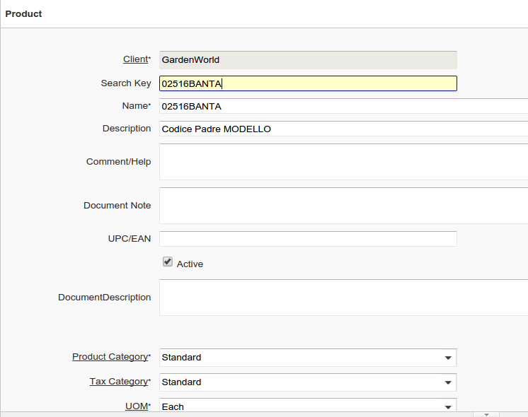

#AD ADD COLUMN LIT_WIDTH (NEW ELEMENT)

#AD ADD COLUMN LIT_HEIGHT = (NEW ELEMENT )

#AD ADD COLUMN LIT_DEPTH = (NEW ELEMENT )

#AD ADD COLUMN AD_Workflow_ID (DICTIONARY)

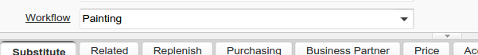

# WORKFLOW : Product Painting Qty 1

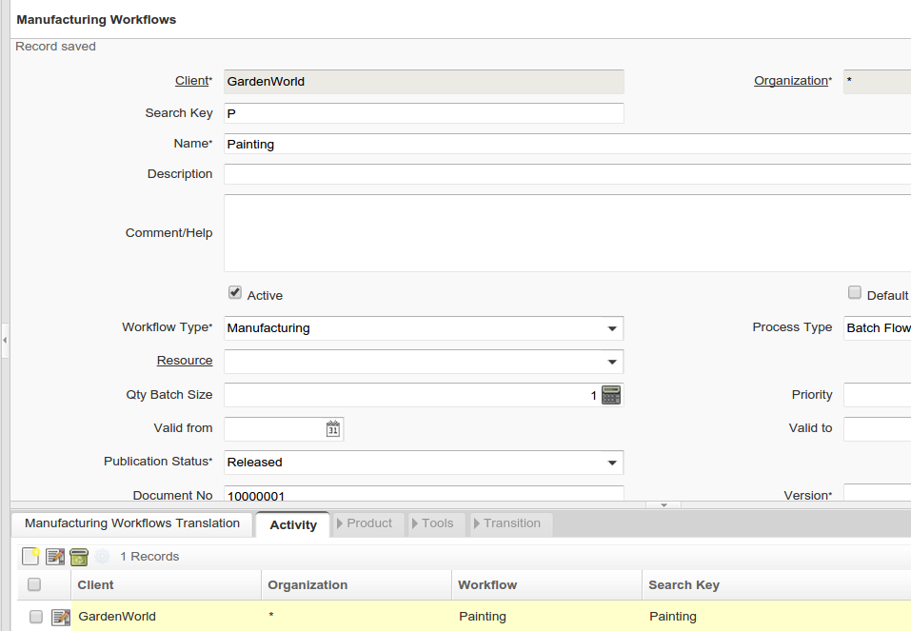

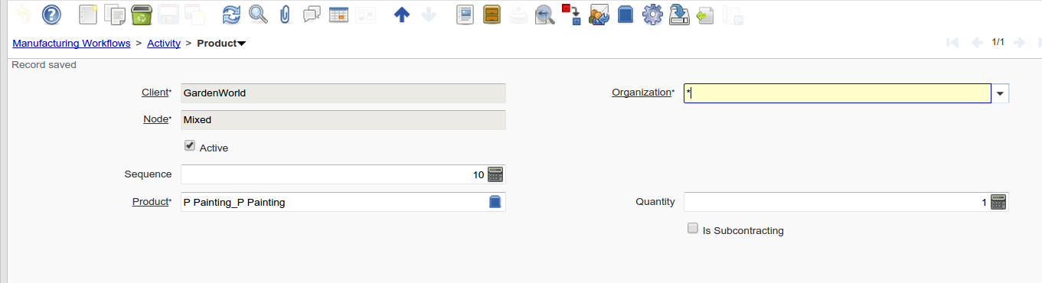

# UOM Standard from iDempiere

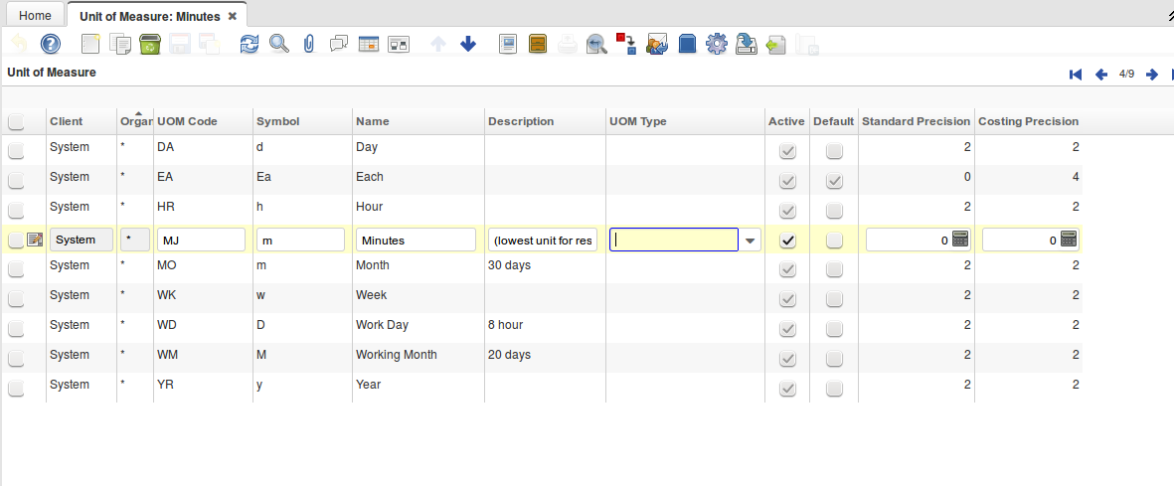

The Tab Conversione is empty

link to conversion table <http://www.convert-me.com/en/convert/area/>

we need to add (for now):

square metre : m2

square millimetere mm2 divide from m2 1.000.000

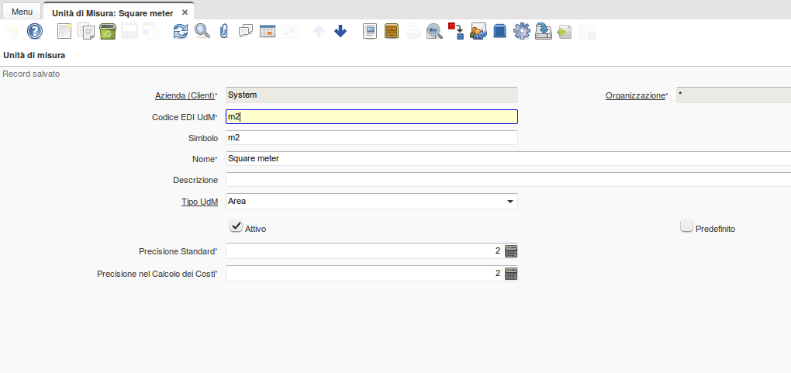

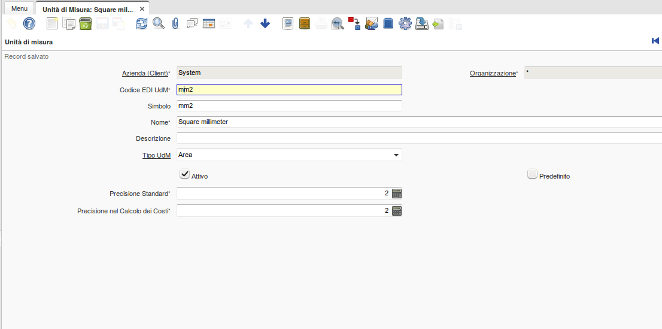

We need a table for calculation (C_UOM_Conversion ) but without product reference to product

In the C_UOM_Conversion Table you have a new field **PRICELISTTYPE**

For PRICELISTTYPE =PLAR ( Area

MODIFICATION ON APPLICATION DICTIONARY

WE NEED TO REMOVE ON THE FIELD OF THE WINDOW TAB :

UNIT OF MEASURE / CONVERSION /PRODUCT : Mandatory overwrite from YES to NO

so we can save the conversion like this

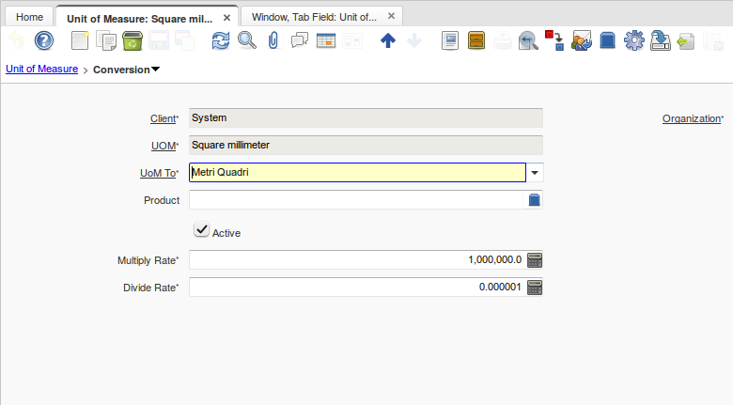

# PRODUCT : Name : Painting UOM

MQ (Metri Quadri=Square Meters) **PRICELISTTYPE**

“AR” per Area

Price is 2 € per UOM ( that means 2 € per Square Meters )

SALES ORDER

Order Line OutProd (LIT_C_OrderLine_OutProd)

(Paintinng) L’attività /Lavorazione ha una unità di misura tipo LIT_PRICELISTTYPE Esempio Area

ANTA UOM NR QtyEntered 100 SIZE : Width : 300 Height 300 (load from product or manual inserted )

(in which uom are this SIZE ? : Table : AD_ClientInfo : C_UOM_Length_ID ) 50000 (for me ) that means millimeters

The Size is : 300x300 = 90000 /1000000 = 0,09 Square Meters x 2 € = 0,18 € per SQ * 200 Nr = 36 € TOTAL Amount

Another Scenario AD_ClientInfo : C_UOM_Length_ID : Meters

On the lines i will have 0,3x0,3 =0,09 Square Meters x 2 € = 0,18 € per SQ * 200 Nr = 36 € TOTAL Amount

Flow Chart of the Process :

Data on Database :

clientinfo ad_client_id=11 c_uom_lenght_ id ml(millimeter) 50000

c_uom_aread_id square meter 1000003

Sales Order : c_order.C_order_id = 1000092

lit_c_orderlineoutprod : id 1000017

qtyentered 100

lit_width 300

lit_heigt 300

c_orderline painting uom (1000003)

CASE A :

You have the Painting in the order line -when you “manage” the product Painting we have “in hand” : a) The Quantity of the finish product 100 pcs

if in the product is not written anything on the **PRICELISTTYPE you can use the standrd method for prices.**

**if there is a pricelistype you have to :**  on the product record of the painting is written that this is AR (AREA ) SO :

#AD NEW FIELD in CLIENT INFO LIT_C_UOM_Area_ID : mm2

#AD NEW FIELD in CLIENT INFO LIT_C_UOM_Volume_ID : (not for now) ..

NEW FIELD in c_uom LIT_C_UOM_Area_ID : mm2 per ogni unita di lunghezza avro la corrispende unita misura direa esempio mm > mm2 m -> m2

AR use for calculation Table : AD_ClientInfo : C_UOM_Length_ID : mm millimeter

AR use for result Table : AD_ClientInfo : LIT_C_UOM_Area_ID : mm2 : millimeter2

on the order line you will have “painting” product

checkin the product we will find PRICELITYPE not null (special price procedure ) = PLAR for this example

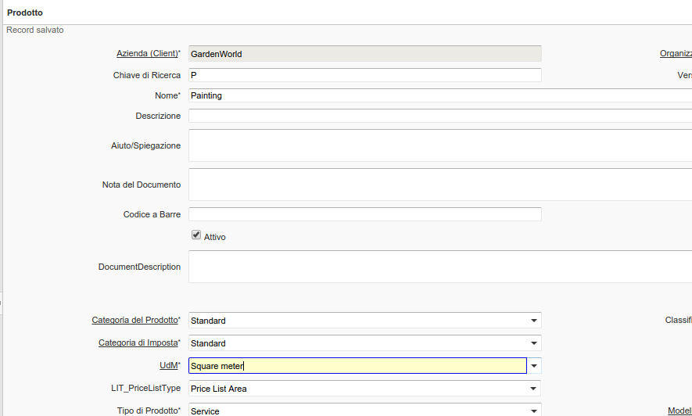

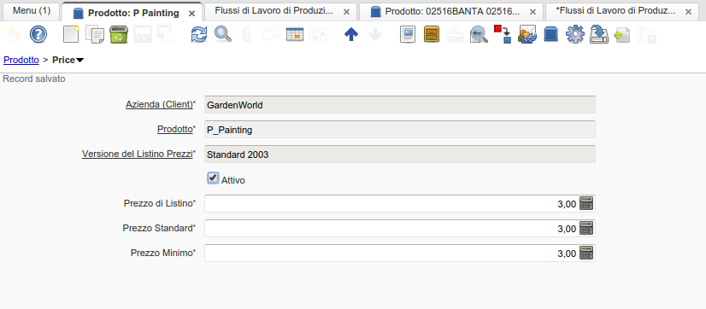

45-56 ) i read and check the Pricelisttype PLAR (fixed hardcoded)

if equal PLAR

I read Clientinfo

i read conversion for clientinfo c_uom_aread_id

I calcluclete the area:

width 300 x height 300 = 90.000 in what uom ? Read the C_UOM_length of hte clieninfo lenght

and read the new field LIT_C_UOM_Aread_ID -> mm2

as the clientinfo.area_

what is the UM of the product (painting ) mq

what is the conversione from mm2 -> mq -> divide 1.000000

so you will

UOM CONVERSION

FROM : AR result = mm2 TO PRODUCT UOM = m2 Divide Rate 1,000,000.0

90000 / 1000000 = 0,09 Multiply per Product qty 200 = 18 square meters

TO pass to the standard class of Price i have the qty 18 the Business Partenr (for vendor brack price) and i get back the price

CASE B :

Client general settings :

Unit measure used for lenght : Table : AD_ClientInfo : C_UOM_Length_ID : m (meter)

Unit measure used for area :Table : AD_ClientInfo : C_UOM_Are_ID : m2 (square meter)

..same sales order

on the order line outprod we will have

Product ANTA width 0,3 height 0,3

Painting UOM : m2 - I need to calculate the price ...

0,300 x0,300 = 0,9 (in square meters ) is AR

In the Product of Painting i have UOM : M2 Pricelisttype AR

UOM CONVERSION

FROM : AR result = m2 TO PRODUCT UOM = m2 NO RECORD MATCH or VALUE 1

0,90000 * 1 = 0,09 m2 Multiply per Product qty 200 = 18 square meters

TO pass to the standard class of Price i have the qty 18 the Business Partenr (for vendor brack price) and i get back the price

# DATABASE/AD CHANGES - DATA INTEGRATION :

MODIFICATION ON APPLICATION DICTIONARY

WE NEED TO REMOVE ON THE FIELD OF THE WINDOW TAB :

UNIT OF MEASURE / CONVERSION /PRODUCT : Mandatory overwrite from YES to NO

GESTIONE PREZZI

LAVORAZIONE € PEZZO

DRILLING (FORATURA ) € UM NR € 1 ( SULLA QTA PRODOTTO FINITO )

LAVORAZIONE € a AREA

PAINTING (VERNICIATURA € UM MQ € 2 (SUL QTA PRODOTTO FINITO )

MONTAGGIO € a ORA

MONTAGGIO UM ORA € 30 (SULLE QTA DICHIARATO DI ORE SUL PRODOTTO FINITO )

> PRICE LIST QTA

-----------------

Siamo a livello di riga lavorazione ..Painting

Dobbiamo avere in memoria questi dati :

PRODOTTO FINITO : ANTA

PRODOTTOFINITO.WIDHT=300

PRODOTTOFINITIHEIGHT =300

PRODOTTOFINITODEPTH =0

UM=NR

QTA= 100

..

PRODOTTOGREZZO.WIDHT=300

PRODOTTOGREZZO.HEIGHT =300

PRODOTTOGREZZO.QTA

IF LIT_PRICELISTTYPE (Se non non fai niente)

LEGGI IL VALORE

IF PLARFP (AREA SUL PRODOTTO FINITO ) (ci sarà PLPZ . .PLOR)

CHECK VALORI MANDATORY :

-PRODOTTOFINITOWIDTH

-PRODOTTOFINITOHEIGHT ,

prendiamo l’unita di misurea lunghezza da ad_client info … nel nostro caso troviamo mm

WiDTH x height = 3000 mm x 3000 mm = 9000000 in mm2 (ad_clientoinfo)

vado nella tabella di conversione con

MQ e MM2 trovi che devi dividere per 1.000.000 quindi trovi 9 mq

moltiplico per la qta 9x100 =900 mq

salvi la qta (900) nel campo qt di painting

Calcoli il prezzo con PRODOTTO.PAINTING - QTA 900 PRICELIST -order

IF PLEAFP (PEZZI ) x drilling

PRENDO PRODOTOFINITO.QTA 100 la salvo su qta della attivita (100) e calcolo il prezzo

IF PLEARP (PEZZI SUL GREZZO )

PRENDO PRODOTOGREZZO.QTA la salvo su qta della attività e calcolo il prezzo

IF PLARRP ( AREA SUL PRODOTTO GREZZO )

CHECK VALORI MANDATORY : PRODOTTOGREZZOWIDTH -PRODOTTOGREZZOHEIGHT ,

prendiamo l’unita di misurea area da ad_client info … nel nostro caso troviamo mm2

WiDTH x height = 3000x 3000 = 9000000 in mm2 (ad_clientoinfo)

vado nella tabella di conversione con

MQ e MM2 trovi che devi dividere per 1.000.000 quindi trovi 9 mq

salvi 9 nel campo qt di painting

Calcoli il prezzo con PRODOTTO.PAINTING - QTA 9 PRICELIST -order